Assessment Parameters

- Solution Completeness (all requirements addressed) – 10 %
- Working solution for each requirement – 20 %
- Comments – 10%
- Coding standards – 10 %
_______________________________________________________________________

Section 1 – Angular 2/4/5 [Marks 70]

- Design the following using Angular 5. Read the JSON(mobile.json) file using Angular Service, & design the following :
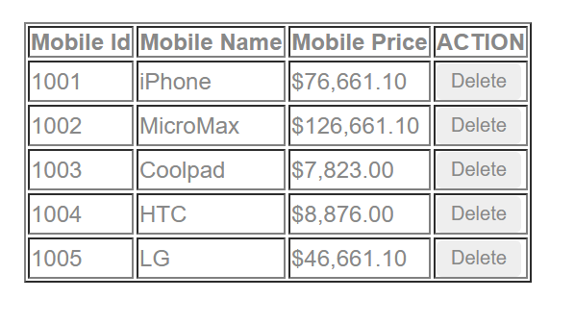

When you click on Delete button particular row will be deleted from list-For example click on 1003 that row is deleted

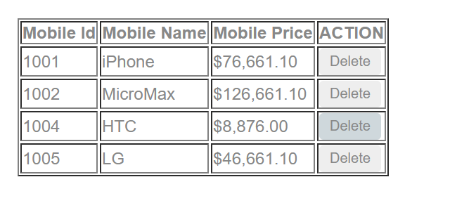
When Click the MobileId, Mobile Price ,Mobile Name it will be sorted in assending order as shown below—For example if clicked on mobile price it will be sorted

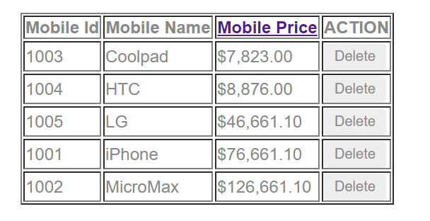

Angular 5
Displaying the form correctly | 5
Fetch the Data from mobile.json | 18
Use of Pipes for dollar | 10
Delete the row when “delete”button pressed | 12
Sorting | 15
Coding convention | 5
Proper naming convention of file | 5

Note: Ask for mobile.json file, don’t upload node_module

